- Project Overview

Objective
Develop an interactive Treasury Management Dashboard that enables Treasury Managers, Analysts, and Senior Management to monitor treasury exposure, liquidity position, and Asset & Liability Management (ALM) using Power BI.
The dashboard consists of three analytical pages:
- Executive Overview
- Liquidity Analysis
- Asset & Liability Management (ALM)
- Technology Stack
Component | Technology
Reporting Tool | Microsoft Power BI Desktop
Data Storage | Excel Files
Data Transformation | Power Query
Data Modeling | Star Schema
Language | DAX
Security | Dynamic Row-Level Security (RLS)

3. Data Sources
Table | Type | Description
Treasury_Transactions | Fact | Treasury transaction details
Cash_Flows | Fact | Daily inflow and outflow transactions
ALM_Snapshot | Fact | Asset and Liability balances
FX_Rates | Fact | Daily exchange rates
Dim_Date | Dimension | Calendar table
Dim_Product | Dimension | Treasury products
Dim_Currency | Dimension | Currency master
Dim_Counterparty | Dimension | Counterparty master
Dim_TreasuryDesk | Dimension | Treasury desk master
UserSecurity | Security | User-to-Treasury Desk mapping

4. Data Model
Star Schema : A Star Schema is a data warehouse modeling technique where a central Fact Table is connected directly to multiple Dimension Tables, forming a structure that looks like a star. It is one of the most widely used designs for business intelligence (BI) reporting and analytics
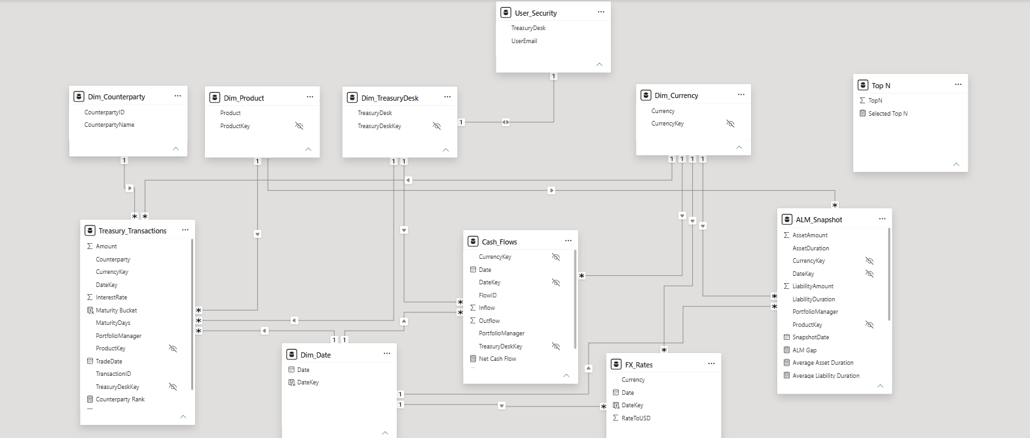
5. Date Dimension
Creates a centralized calendar table that automatically generates a continuous range of dates based on the minimum and maximum dates available in the Power BI data model. It serves as the standard date dimension for all time-based analysis.

Dim_Date = CALENDARAUTO()
6. Calculated Columns
Creates calculated columns like DateKey, Maturity Bucket etc…
- DateKey = FORMAT(Dim_Date[Date],"YYYYMMDD")

- Maturity Bucket =
SWITCH(
TRUE(),
Treasury_Transactions[MaturityDays] <= 30, "0–30 Days",
Treasury_Transactions[MaturityDays] <= 90, "31–90 Days",
Treasury_Transactions[MaturityDays] <= 180, "91–180 Days",
Treasury_Transactions[MaturityDays] <= 365, "181–365 Days",
"365+ Days"
)

7. Measures
Created Measures based on report requirement find all measure from document KPI Dictionary.

- Total Treasury Exposure
- Total Assets
- Total Liabilities
- Net Exposure or ALM GAP
- Total Inflow
- Total Outflow
- Net Cash Position
- Liquid Assets
- Short-Term Obligation
- Liquidity Ratio
- Top N
- Selected Top N
- Counterparty Rank
- Top N Exposure
- Average Asset Duration
- Average Liability Duration
- Duration Gap

8. Report Pages

Page1 : Executive Overview
KPIs
- Total Treasury Exposure
- Net Exposure
- Net Cash Position
- Liquidity Ratio
Visuals
- KPI Cards
- Treasury Exposure Trend
- Exposure by Treasury Desk
- Exposure by Product
- Top N Counterparties
Page 2 : Liquidity Analysis
KPIs
- Total Inflows
- Total Outflows
- Net Cash Flow
Visuals
- Daily Cash Flow Trend
- Inflow vs Outflow
- Maturity Breakdown
- Cash Flow by Treasury Desk
Page 3 : ALM Dashboard
KPIs
- Total Assets
- Total Liabilities
- ALM Gap
- Duration Gap
Visuals
- Assets vs Liabilities Trend
- Product Breakdown
- Duration Analysis
- Currency Exposure
9. Row-Level Security
User_Security Table :
UserEmail | TreasuryDesk
analyst_liquidity@bank.com | Liquidity
analyst_funding@bank.com | Funding
analyst_alm@bank.com | ALM
analyst_fx@bank.com | FX
treasury.manager@bank.com | ALL

CurrentUser = USERPRINCIPALNAME()

VAR UserDesk =
LOOKUPVALUE(
UserSecurity[TreasuryDesk],
UserSecurity[UserEmail],
CurrentUser
)

RETURN

UserDesk="ALL"
||
Dim_TreasuryDesk[TreasuryDesk]=UserDesk

10. Report Filters
Global Slicers
- Date
- Currency
- Treasury Desk
- Product
- Counterparty
- Top N
11. Performance Optimization
Implemented
- Star Schema
- Dimension Tables
- Single Direction Relationships
- Measure-based calculations
- Avoided unnecessary calculated columns
- Used variables (VAR) where appropriate
- Minimized bidirectional filtering
- Optimized DAX with DIVIDE() instead of /

